Multidisciplinary Collaboration Treatment of Invasive Cervical Resorption (ICR) Using Bioactive Bioceramic Materials and Injectable Composite based on CBCT evaluation:
A Case Report

Fani Pangabdian¹, Diana Soesilo², Aprilia³, Eddy Hermanto⁴, Sarianoferni⁵
^{1,2,3}Department of Dental Conservation, Dentistry Faculty, Universitas Hang Tuah Surabaya, Indonesia
⁴Department of Oral and Maxillofacial Surgery, Dentistry Faculty, Universitas Hang Tuah Surabaya, Indonesia
⁵Department of Oral and Maxillofacial Radiology, Dentistry Faculty, Universitas Hang Tuah Surabaya, Indonesia

Correspondence:
Fani Pangabdian
Department of Dental Conservation, Dentistry Faculty, Universitas Hang Tuah
Address: Jln. Arief Rachman Hakim No.150, Surabaya 60111, Indonesia.
E-mail: fani.pangabdian@hangtuah.ac.id . Phone +62 817 386 917.

Abstract
Background: Invasive Cervical Resorption (ICR) is an aggressive resorptive lesion that may lead to structural damage of permanent teeth and eventual tooth loss if not managed at an early stage. Objective: This report aims to describe the multidisciplinary collaborative management (conservative dentistry, oral surgery, and radiology) in a case of ICR. Case: A 35-year-old female patient with a history of trauma to the left maxillary central incisor and previous fixed orthodontic treatment. Clinical examination and Cone-Beam Computed Tomography (CBCT) confirmed the presence of Heithersay Class III ICR with subcrestal involvement. Case Management: Treatment procedures included root canal therapy using a bioceramic sealer, surgical debridement for the removal of granulation tissue, and restoration of the defect using bioactive bioceramic materials, followed by an injectable composite restoration for esthetic rehabilitation. Conclusion: Successful management of ICR is highly dependent on accurate CBCT-based diagnosis, the use of biocompatible materials, and a minimally invasive multidisciplinary collaborative approach.

Keywords: CBCT, Heithersay Class III, Invasive Cervical Resorption, Multidisciplinary Management, MTA.

Introduction
Root resorption is a pathological condition characterized by progressive loss of dental hard tissues, particularly affecting the root structure, and may ultimately lead to tooth loss if left untreated [1]. It is broadly classified into internal and external resorption. Internal resorption originates within the pulp chamber and progresses outward, whereas external resorption initiates from the external root surface and may extend toward the pulp space [2].
Invasive Cervical Resorption (ICR) represents a distinct subtype of external resorption that originates at the cervical region of the tooth, typically near the cemento-enamel junction (CEJ). This condition is characterized by its progressive and destructive behavior. In its early stages, ICR is frequently asymptomatic and may be misinterpreted as cervical caries, leading to delayed diagnosis [1,3].
The term ICR was introduced and popularized by Heithersay, who proposed a classification system based on lesion severity. This classification includes four categories: Class I (small superficial lesion), Class II (well-defined lesion approaching the pulp), Class III (deeper invasion extending into the coronal third of the root), and Class IV (extensive lesion beyond the coronal third) [4,5].
The etiology of ICR is considered multifactorial. Commonly associated predisposing factors include dental trauma, orthodontic treatment, internal bleaching procedures, periodontal surgical interventions, deep cervical restorations, and previous endodontic treatment [6]. Despite these associations, the exact pathogenesis of ICR remains incompletely understood, and further research is required to elucidate the underlying mechanisms.
Clinically, ICR often presents without symptoms. However, in certain cases, a characteristic pinkish discoloration (commonly referred to as a “pink spot”) may be observed, along with bleeding upon probing. In the early phase, the pulp typically remains vital, making vitality testing crucial in differentiating ICR from other conditions such as cervical caries, internal resorption, cervical root fractures, or combined endodontic-periodontal lesions [7].
Radiographically, ICR appears as an irregular radiolucency in the cervical region with poorly defined margins. A key distinguishing feature from internal resorption is the preservation of the root canal outline. CBCT imaging is strongly recommended to enhance diagnostic accuracy, as it allows three-dimensional assessment of lesion extent, proximity to the pulp, and involvement of surrounding structures, thereby facilitating precise treatment planning [4,8]

Case
A 35-year-old female patient presented to RSGM Nala Husada with a chief complaint of a reddish swelling in the upper left anterior gingival region. Anamnesis revealed a history of dental trauma four years prior, followed by fixed orthodontic treatment. Initially, the patient experienced pain; however, the symptoms gradually subsided over time. Clinical examination revealed discoloration on the labial surface of tooth 21 in the cervical region. Upon probing, a “catch” was detected, accompanied by bleeding. Percussion (+), palpation (+), and vitality testing indicated that the tooth was non-vital (Figure 1).
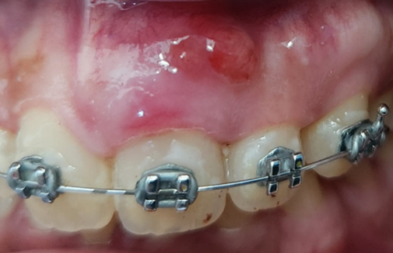

Fig.1 Clinical Picture of ICR
Radiographic examination demonstrated an irregular radiolucent area with a mottled appearance. The lesion involved enamel and dentin, extended close to the pulp, and spread into the coronal one-third of the root. Based on the two-dimensional (2D) classification system according to Heithersay, this condition was categorized as Class III, as it showed deep dentin invasion extending into the coronal third of the root (Figure 2A). CBCT analysis provided a more detailed visualization, revealing a radiolucent area invading enamel and dentin approaching the pulp space, as well as thinning of the buccal cortical plate (Figures 2A, 2B)
C
B
A
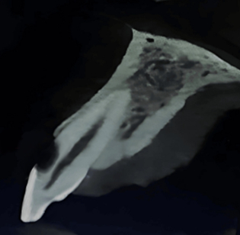
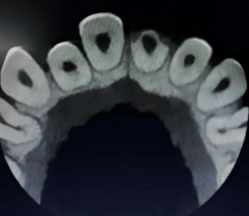
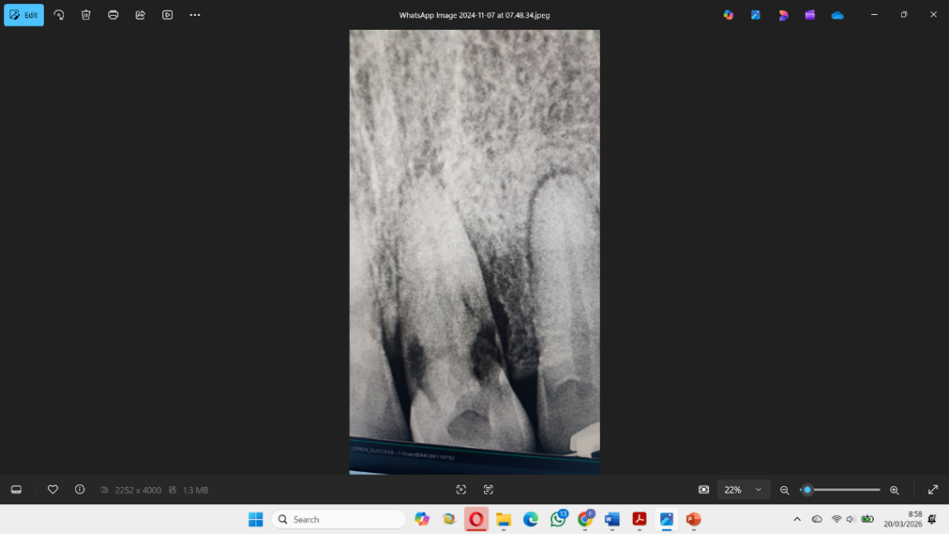

Fig.2 A. Preoperative periapical radiograph. B. CBCT image in sagittal section corresponding to tooth number 21. C. CBCT axial section view of tooth number 21

Case Management
Following the signing of informed consent by the patient, root canal treatment was initiated under rubber dam isolation. Access was prepared through the palatal aspect, followed by accurate working length determination using an apex locator and radiographic confirmation. Biomechanical preparation began with glide path establishment using a #10 K-file, followed by rotary instrumentation up to size F3. The irrigation protocol was performed intensively using 2.5% sodium hypochlorite (NaOCl) and 17% EDTA at each instrument change. As a disinfection step, calcium hydroxide was applied as an intracanal medicament for 14 days. Subsequently, root canal obturation was performed using gutta-percha and a bioceramic sealer prior to surgical intervention.
At the subsequent visit, a surgical procedure was performed to repair the resorptive defect under local anesthesia by creating a full-thickness mucoperiosteal flap on the labial side. After flap reflection, granulomatous tissue extending from the labial surface to the cervical third of the crown was observed. The resorptive tissue was carefully curetted until bleeding was controlled. The defect area was then disinfected using 5.25% NaOCl to reach microscopic areas, followed by closure using a biocompatible material, Mineral Trioxide Aggregate (MTA), according to the manufacturer’s instructions, and flap repositioning was performed (Figure 3).
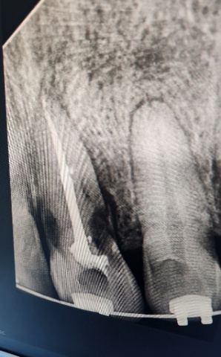

Fig.3 Root canal treatment of tooth 21
After four weeks, the patient was recalled for evaluation of soft tissue healing following the surgical procedure. Subsequently, restoration of the cervical region was performed using an injectable composite (Figure 4A,4B).
A
B
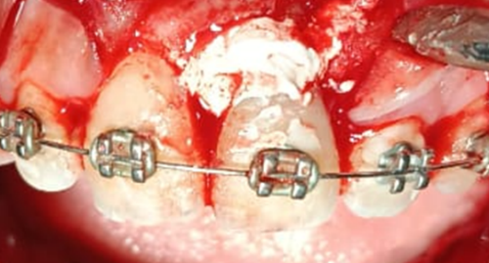
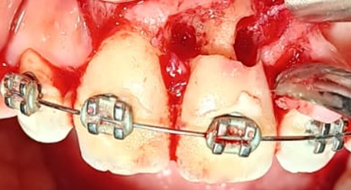

Fig.4 A. ICR open flap. B. ICR therapy with MTA application
Radiographic evaluation after six months demonstrated successful healing, indicated by the absence of periapical abnormalities and healthy surrounding bone conditions (Figure 5A,5B). Clinically, the treated tooth remained asymptomatic, with healthy gingiva and no signs of pathological conditions in the periodontal tissues.
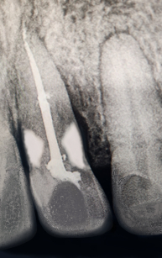
A

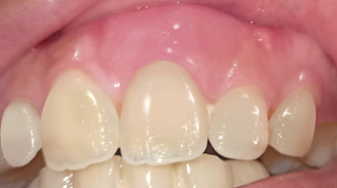
B

Fig.5 A. Radiography of ICR recovery post operation. B. ICR recovery post operation
Discussion
The management of ICR is primarily determined by the extent and severity of the lesion. The fundamental objective is to arrest the resorptive process through complete removal of resorptive tissue, followed by defect restoration using biocompatible materials [1,9]. In the present case, the lesion was classified as Heithersay Class III, indication substantial structural involvement. Therefore, a combined approach involving endodontic therapy and surgical access was necessary to adequately manage the subgingival defect [9].
The pathogenesis of ICR is thought to initiate with damage to the cervical cementum, resulting in exposure of underlying dentin. This exposure facilitates the infiltration of clastic cells, such as osteoclasts or odontoclasts, derived from periodontal tissues [5,10]. Additionally, proliferation of granulation tissue has been proposed as a contributing factor, allowing the lesion to expand both laterally and apically within dentin [7].
Diagnosis of ICR can be challenging due to its variable clinical presentation. CBCT imaging plays a critical role in improving diagnostic accuracy by providing detailed information regarding lesion location, extent, and structural involvement [11].
In this case, MTA was selected as the restorative material due to its superior biocompatibility, sealing ability, and osteoinductive properties, making it particularly suitable for irregular resorptive defects [7,12]. Furthermore, MTA has been shown to promote dentin bridge formation and enhance reparative dentinogenesis.
The use of a bioceramic sealer in conjunction with gutta-percha contributes to improved sealing ability and reduced microleakage. Unlike conventional materials, bioceramics exhibit minimal dimensional change during setting, thereby maintaining long-term seal integrity [8].
For coronal restoration, injectable composite was utilized due to its favorable handling properties and high filler content. Compared to conventional flowable composites, it provides enhanced mechanical strength, superior marginal adaptation, and improved wear resistance, making it suitable for cervical restorations requiring both functional durability and esthetic outcomes [12].
At the six-month follow-up, the absence of clinical symptoms and radiographic pathology indicated successful treatment. However, long-term follow-up studies are necessary to further validate the effectiveness and durability of this treatment approach.

Conclusion
Effective management of invasive cervical resorption requires accurate diagnosis and meticulous treatment planning, with CBCT serving as an essential diagnostic tool for precise lesion assessment.
Surgical intervention facilitates direct access to the resorptive defect, enabling thorough debridement. The use of MTA as a restorative material promotes periodontal healing and serves as a long-term barrier against further resorptive progression.
Additionally, the application of injectable composite enhances structural integrity and supports coronal restoration, resulting in favorable functional and esthetic outcomes over time.

Acknowledgements
The authors would like to thank Hang Tuah University for supporting this case report.

References
- Nireeksha BN, Harsha P, Naik BD, Setty S, Horatti P: Management of invasive external cervical resorption in maxillary anterior teeth: a case report. J Restor Dent Endod. 2022, 1:63-6. 10.25259/jrde_2_2022
- Garg N & Garg A: Textbook of Endodontics, 4th ed. New Delhi: Jaypee Brothers Medical Publisher (P) Ltd; 2022.
- da Cunha Isaltino M, da Silva Souza C, de Oliveira NG, de Melo Júnior PM, Velozo Telles CT, de Albuquerque DS: Endodontic and surgical management of an invasive cervical resorption in a maxillary central incisor: a case report. Iran Endod J. 2023, 18:168-73. 10.22037/iej.v18i3.41385
- Ghabraei S, Bolhari B, Hashemi N, Gharehchahi H: Conservative management of an advanced external cervical resorption with internal approach using bio-ceramic materials: a case report. Clin Case Rep. 2024, 12:e8378. 10.1002/ccr3.8378
- Howait M, Shaker M, Aljuhani H, AlMohnna M: External cervical resorption: a case report and brief review of the literature, and treatment algorithms. J Contemp Dent Pract. 2021, 22:298-303. 10.5005/jp-journals- 10024-3013
- Chen Y, Huang Y, Deng X: External cervical resorption-a review of pathogenesis and potential predisposing factors. Int J Oral Sci. 2021, 13:19. 10.1038/s41368-021-00121-9
- Lin Y, Thumbigere-Math V, Kishen A, He J: Unraveling the etiology and pathogenesis of multiple cervical root resorption - a scoping review. J Endod. 2025, 10.1016/j.joen.2025.02.012
- Bardini G, Orrù C, Ideo F, Nagendrababu V, Dummer P, Cotti E: Clinical management of external cervical resorption: a systematic review. Aust Endod J. 2023, 49:769-87. 10.1111/aej.12794
- Mount GJ, Hume WR, Ngo HC, Wolff MS, editors. Preservation and restoration of tooth structure. 3rd ed. New York: John Wiley & Sons; 2016
- Ritter, A. V., Boushell, L. W. & Walter, R., 2019. Sturdevant's Art and Science of Operative Dentistry. 7th ed. North Carolina: Elsevier Inc.
- Torabinejad, M., Fouad, A. F. & Shabahang, S., 2021. Endodontics: Principles and Practice. 6th ed. North Carolina: Elsevier Inc. https://doi.org/10.1111/j.1365-2591.2009.01665.x
- Stefanac, S. J. & Nesbit, S. P., 2017. Diagnosis and Treatment Planning in Dentistry. 3rd ed. North Carolina: Elsevier Inc. https://doi.org/10.1093/med-psych/9780190608453.003.0008

